Using a Grid-Search Method to model the orbital parameters of Binary System 1 Spu

Jay Franck

San Diego State University and Mount Laguna Observatory
Submitted: 04 November 2010

Abstract

The orbital parameters P (period), T₀ (arbitrary time of periastron passage), the eccentricity e, ω (argument of periastron), the semiamplitude of the velocity K, and the systemic velocity γ were determined using a Grid-Search method to model the radial velocities of the system. The fitness of the model was measured using a χ² test from intermittent radial velocity observations from Mount Laguna Observatory. The data from Mount Laguna consisted of a Julian Date and a corresponding radial velocity. The Grid Search tested a range of possible parameters, saving the parameters in each iteration that coincided with the smallest χ² and created a plot of Radial Velocity vs. Orbital Phase with the line of best fit through the observed data set, where the range of initial parameter selection was based on previously used numerical methods. Successive iterations of the grid search used the previous results to further refine the model.
I. Introduction

The orbital elements P, T₀ , e, ω, K and γ are the orbital elements that can be used to almost fully describe the orbit of a binary system. Using Equation 2.45 from Hilditch on page 42, we can calculate the radial velocity at any true anomaly θ of the orbit using those orbital elements. Each orbital element has its own importance. For instance, the element K, along with the Period and the eccentricity of the orbit, will yield the inclination of the orbit, and gamma (γ ) is the motion of the center of mass of the system, an important quantity.

From methods in previous works (Homework 4, Homework 6) a rough estimate of each of the orbital parameters was determined. Homework 4 utilized the Lafler-Kinman method to get find a value for the period. This period was then used as an inital parameter in Homework 6, which was especially instrumental in the Grid-Search's initial parameters. HW 6 utilized visual modeling of the system using plots of the trial Radial Velocity vs. Phase fits plotted with actual data. After many visual iterations, a general range for the parameters was found (see Figure 1 for the final result of this method).

This Grid-Search method uses the χ² test in order to determine the fitness of the model. Assuming 1σ errors, the test can be written as the difference between the observed radial velocities for a given phase and the calculated radial velocities of the model, or . The smaller the value of χ2 , the better the fitness of the model.
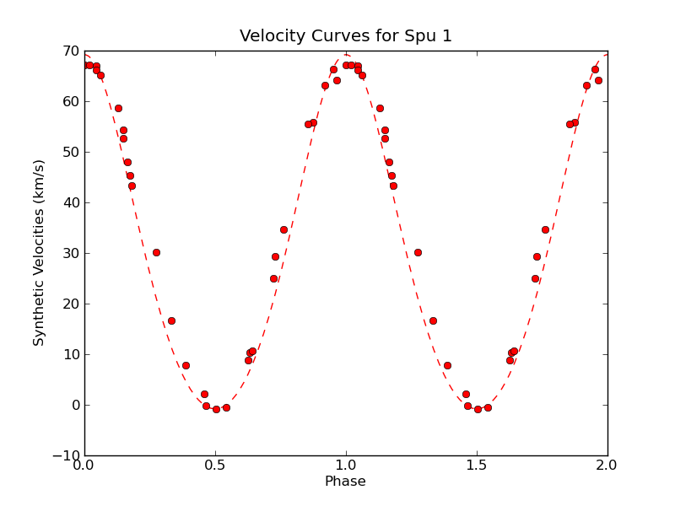
Figure 1: Visual optimization of 1 Spu using the graphical technique "Guess-and-Plot" detailed in HW6. Estimates of the orbital parameters were found using this method. P~10.338 days,
T₀~45785.66
K~35±1 km/s
γ~30±1 km/s
ω~0º±.03º
e~.12±0.02
χ² =1566.301

Using the estimate parameters, a series of nested loops was constructed to form a Grid-Search. Each loop consists of a list of candidate values for each parameter, centered on the estimates from HW6. The nested loops iterate through each possible combination of parameters, and the fitness is calculated. After each iteration, the fitness is compared to the fitness of the previously best parameters. If the newest model's fitness is found to be superior, those parameters are saved and set as the new benchmark.

II. Program Specifics

Without any modern algorithms, Python is at a serious disadvantage when it comes to modeling parameters (a Python version of Levenberg-Marquardt from 2002 exists, but is no longer functional with the current release of Python). However, if the initial estimates of the parameters supplied to a Grid-Search program, it is quite probable a satisfactory result can be achieved using many iterations and user intervention into the program. As explained previously, the Grid-Search method utilizes a list (single dimensional array in Python) of candidate parameters spread around the initial estimate of that parameter. For each value that needs to be modeled, a loop is constructed. Therefore, each combination of parameters is modeled and its fitness tested. The complete program code has been appended to this document for the reader's convenience.

It is readily apparent that this method lacks efficiency, and that the computation time grows exponentially with the number of candidate values. It is absolutely crucial to this method, therefore, that the number of candidates per parameter remain small for each optimization, and also that the initial estimates be quite close to the actual values. As can be seen from Figure 1, the initial estimates are passable, but certainly not perfect.

The outline of the program is pretty simple. Data from Mount Laguna is read in from a text file, and the Radial Velocity and Times are each deposited in separate lists, 'obsVel' and 'times' respectively. The radial velocity list is doubled in order to illustrate two full phases. Six lists are created, one for each of the parameters to be modeled. Six variables are also initialized, which will hold the best values for each parameter. For each list, the best estimate is entered, along with a 5%-10% spread of values on each side (the spread of values was based on the estimated errors found in HW6). Approximately five to seven candidate values were included for each parameter to be iterated through.

The program would then iterate through the first P and the first periastron time candidates, and would use these values and the list of observation times to calculate the corresponding phases using another module, storing the results in a seperate list, 'obsPhase', and then doubled to match the doubled radial velocity list, 'obsVel'. Then the program would catch the first eccentricity candidate. The mean anomaly would be calculated from the phase, and two subprocesses are called. The first subprocess calculates the eccentric anomaly using the Newton-Raphson iteration method and the mean anomaly. The second subprocess calculates the true anomaly from the eccentric anomaly, and stores each θ in a list, 'theta'.

The program then iterates through the first K and γ values. The program then calls a subprocess to calculate the radial velocity of each true anomaly in the list, and then calculates the resulting χ² of that particular model. The program checks to see if this χ² is better than any previous models; if it is, it stores the values and the fitness. If not, it continues to cycle through each combination of values. After each combination of parameters is calculated, a line of best fit is constructed, and the actual values are plotted with the best fit line in a Radial Velocity vs. Phase diagram.

Once the best values are calculated from the initial values, a new list of values is constructed for each of the parameters, centered on the 'best' values from the previous computation. Using the value of χ² as a guide (as well as the plot from each set of initial values), each parameter value is slowly optimized until the program has reached its capacity to decrease the χ² any more.

III. Calculations and Results

From previous numerical methods, the value of the period and T₀ were relatively well known, and therefore initial values had the least spread of any of the parameters. The first execution of the program had values of five values of P =10.338±0.04 days and five values of T₀~45785.66±0.05 days (the ± represents the total range of values). The initial values of K were 35±4km/s over 9 values, and the initial values of γ were 30±3km/s over 7 values. The values of ω had the highest confidence in HW6, and so only consisted of 4 values [0,0.5,1.0,1.5], with a strong certainty that the value was 0. The eccentricity on the other hand had a horrible initial estimate of e~.12±0.05, over a range of 5 values. See Figure 2 for an example of the first computation of the model parameters.

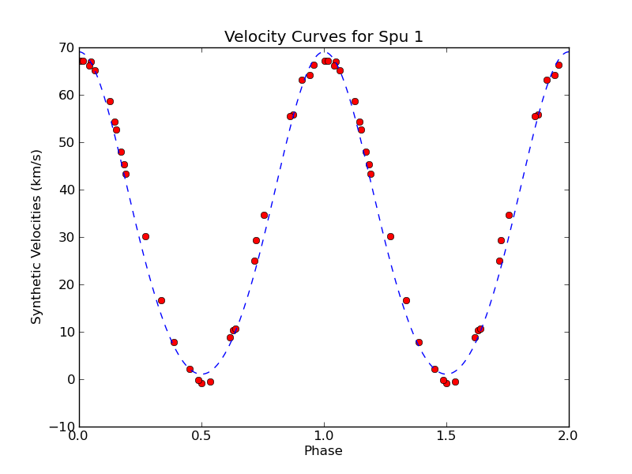

Figure 2: This the Radial Velocity vs. Phase plot for the initial execution of the program. Notice the poor fit, especially at the minimum and maximum values. Optimization of the eccentricity of the system immensely improved the fit over very few iterations.

After the initial values were iterated through, many subsequent computations were performed. A conservative estimate would be 100 executions of the program over a wide range of values, each execution intent on minimizing the χ² value. The spread of the values of the parameters would be shortened until the subsequent changes in the parameter values were negligible. The results of this Grid-Search can be found in Table 1, and the model plot in Figure 3 with the final values. The errors for each value were determined by altering each parameter until the χ² value changed by ±1.

The largest change from the initial values was the value for the eccentricity, which turned out to be much less than the initial estimate, and almost perfectly circular (e = 0.0205). The value of K turned to be problematic if the spread of values went too high (K>34). The χ² value would increase drastically, and the best fit line would be much worse, yet the Grid-Search would return the highest K values as the best value. This slight defect was quickly skirted and more suitable χ² values were found.

 | Value | Error
Period (P) | 10.3365 days | ±0.0002 days
Time of Periastron (T₀) | 45785.665 | ±0.005
Semi-amplitude of the Velocity (K) | 33.835 km/s | ±0.175
Systemic Velocity (γ) | 33.40 km/s | ±0.15
Argument of Periastron (ω) | 0.002º | ±0.002º
Eccentricity (e) | 0.008 | ±.003
χ² value | 57.7347
Table 1: This table lists the best results found using the Grid-Search method and the 1 χ² value errors associated with each. At the bottom lists the χ² value for the entire model.
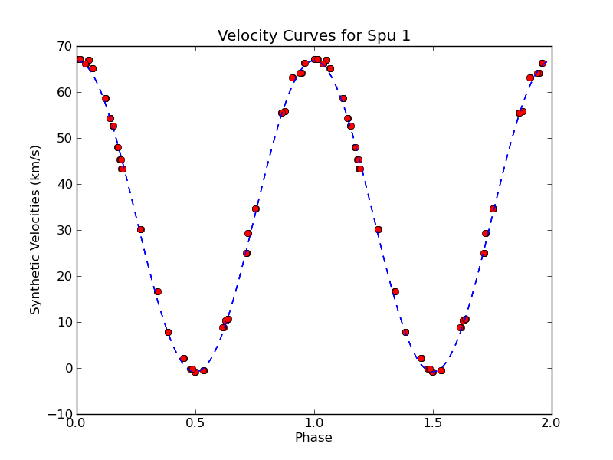
Figure 3: The Radial Velocity vs. Phase Diagram with the observed points as the dots, and the best fit represented the dashed line. This result is after numerous optimizations and executions as detailed above, with the orbital parameters that were used displayed in Table 1. Almost every observation point is in contact with the best fit line.

References

Franck, Jay. Homework 4, Homework 6. Astronomy 610, Fall 2010. San Diego State University

Hilditch, R.W. An Introduction to Close Binary Stars. Cambridge University Press; 1 edition. Mar 2001

Orosz, J. Astronomy 610 Lecture Series, Fall 2010. San Diego State University

